Objective:
Use Subqueries, CTEs, and Window Functions to analyze sales data from the Superstore dataset.

Tasks

Step 1: Setup Data
- Import the Superstore dataset into a table named superstore_raw.
- Create these 3 tables from it:
  - customers
  - orders
  - products
- Insert data into these tables using SELECT DISTINCT.

Step 2: Perform Required Queries
Write and execute SQL queries for each of the following:

- Find all orders where sales are greater than the average sales. (Subquery)

ANSWER 1:

SELECT `Order ID`,`order Date` `Customer Name`,`Sales`
FROM superstore_raw
WHERE Sales >(SELECT AVG(Sales) FROM superstore_raw);

OUTPUT:
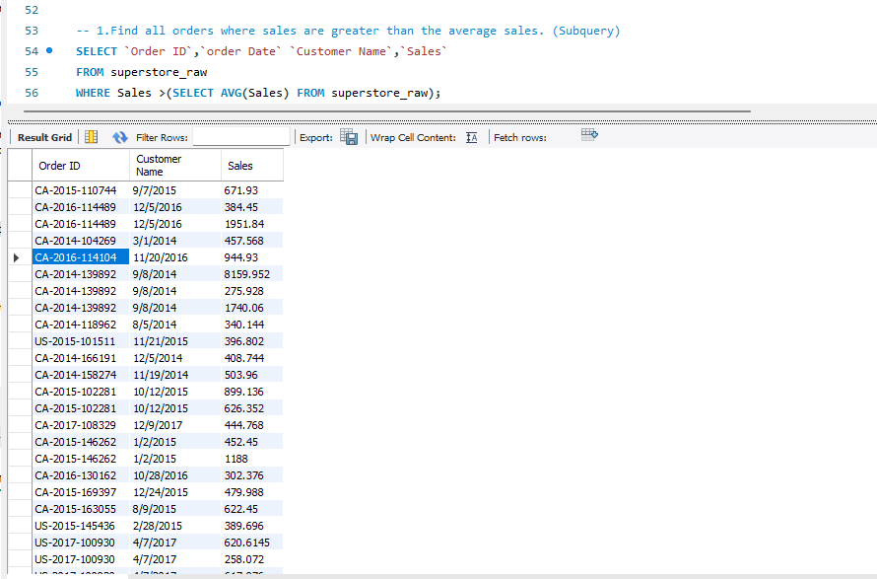

- Find the highest sales order for each customer. (Subquery)

ANSWER 2:

SELECT s.`Customer Name`,s.`Order ID`,s.Sales
FROM superstore_raw s
JOIN
(SELECT `Customer Name`,MAX(Sales) AS Highest_Sales
FROM superstore_raw
GROUP BY `Customer Name`) m
ON
s.`Customer Name` = m.`Customer Name`
AND s.Sales = m.Highest_Sales;

OUTPUT:
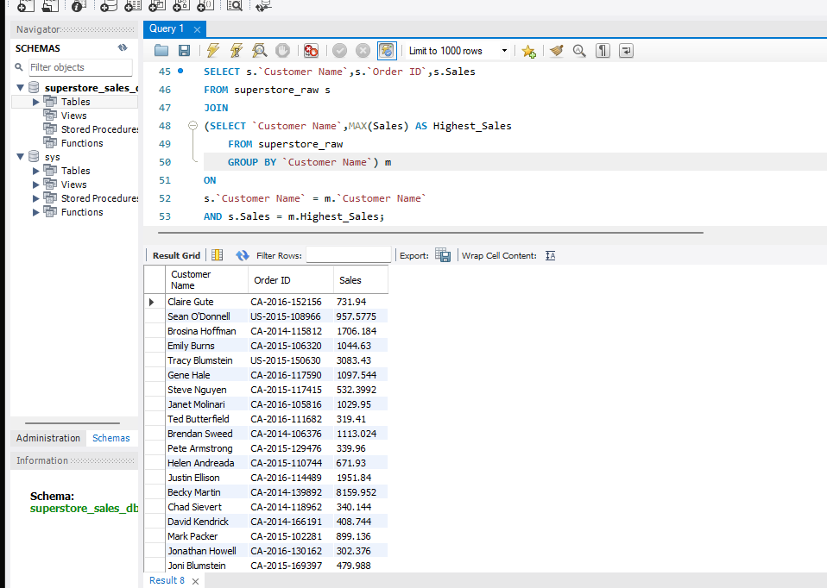

- Calculate total sales for each customer. (CTE)

ANSWER 3:
WITH
customer_sales AS
(SELECT `Customer Name`,SUM(Sales) AS Total_Sales
FROM superstore_raw
GROUP BY `Customer Name`)
SELECT *FROM customer_sales;
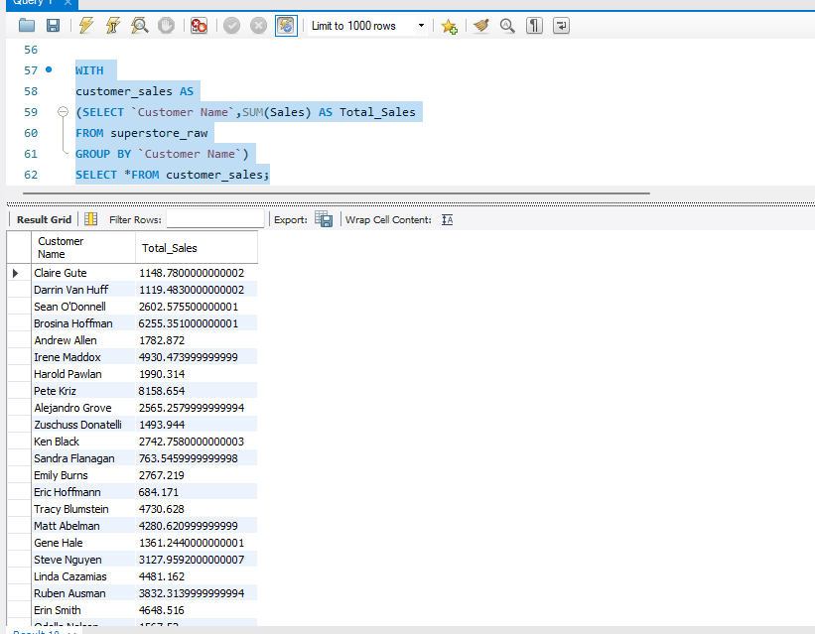
- Find customers whose total sales are above average. (CTE + Subquery)

ANSWER:
WITH
customer_sales AS
(SELECT `Customer Name`,SUM(Sales) AS Customer_Sales
FROM superstore_raw
GROUP BY `Customer Name`)
SELECT `Customer Name`,Customer_Sales
FROM customer_sales
WHERE Customer_Sales >(SELECT AVG(Customer_Sales)
FROM customer_sales);

OUTPUT:
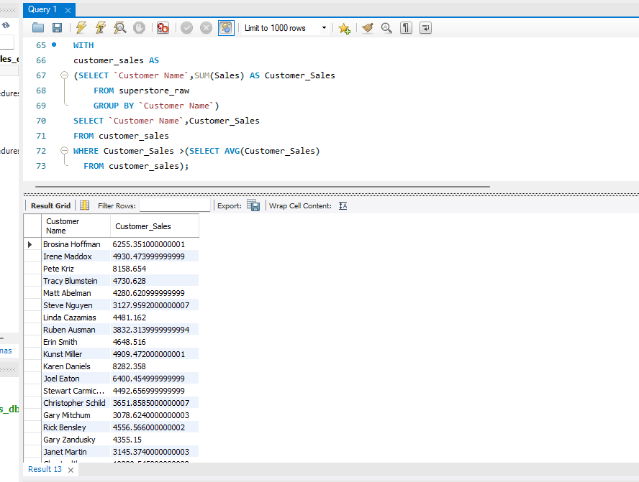

- Rank all customers based on total sales. (Window Function)
ANSWER 5:

SELECT `Customer Name`,SUM(Sales) AS Total_Sales,
RANK() OVER (ORDER BY SUM(Sales) DESC) AS rnk
FROM superstore_raw
GROUP BY `Customer Name`;

OUTPUT:

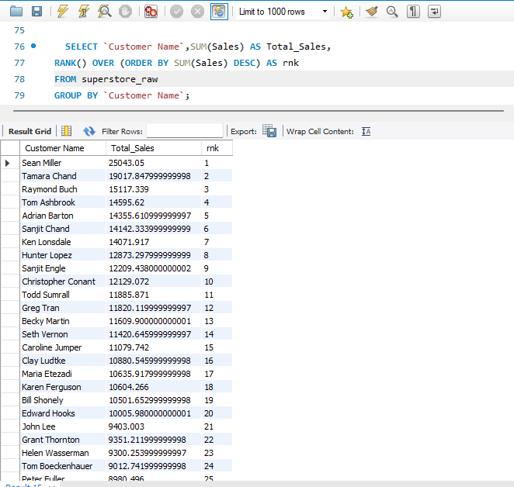
- Assign row numbers to each order within a customer. (Window Function + PARTITION BY)

ANSWER 6:

SELECT`Customer Name`,`Order ID`,Sales,
ROW_NUMBER() OVER(PARTITION BY `Customer Name` ORDER BY `Order ID`) AS Order_Row_Number
FROM superstore_raw;

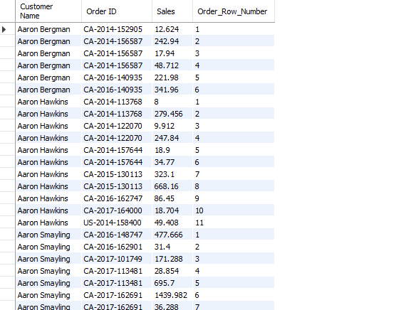
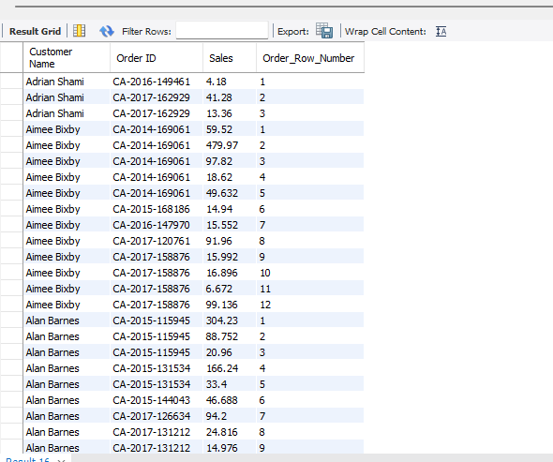
- Display top 3 customers based on total sales. (Window Function)
ANSWER 7:

SELECT * FROM
(SELECT `Customer Name`, SUM(Sales) AS Total_Sales,
RANK() OVER (ORDER BY SUM(Sales) DESC) AS Sales_Rank
FROM superstore_raw
GROUP BY `Customer Name`)
ranked_customers
WHERE Sales_Rank <= 3;

OUTPUT:
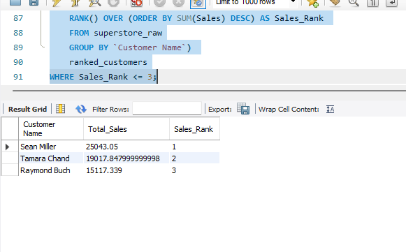

Step 3: Final Combined Query
Write one final query that shows:
- Customer Name
- Total Sales
- Rank
(Use JOIN + CTE + Window Function together)

FINAL QUERY:

WITH
customer_sales AS
(SELECT c.customer_name, SUM(o.sales) AS Total_Sales
FROM customers c
JOIN orders o
ON c.customer_id = o.customer_id
GROUP BY c.customer_name)
SELECT customer_name, Total_Sales,
RANK() OVER (ORDER BY Total_Sales DESC) AS s_rnk FROM customer_sales;

OUTPUT:
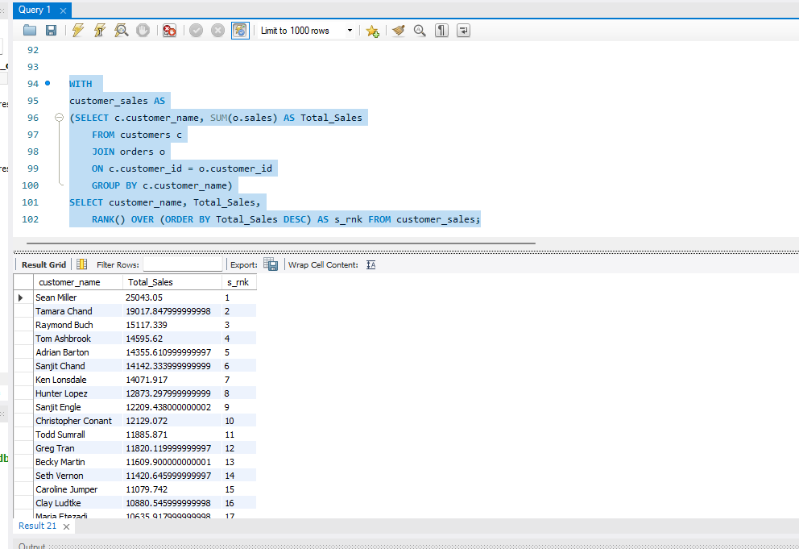

Mini Project: Customer Sales Insights
Answer the following using SQL:
- Who are the top 5 customers?
ANSWER 1:

SELECT * FROM
(SELECT `Customer Name`, SUM(Sales) AS Total_Sales,
RANK() OVER (ORDER BY SUM(Sales) DESC) AS Sales_Rank
FROM superstore_raw
GROUP BY `Customer Name`) top_5_customers
WHERE Sales_Rank <= 5;

OUTPUT:
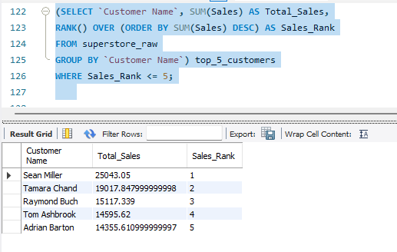
- Who are the bottom 5 customers?

ANSWER 2:

SELECT * FROM
(SELECT `Customer Name`,SUM(Sales) AS Total_Sales,
RANK() OVER (ORDER BY SUM(Sales) ASC) AS Sales_Rank
FROM superstore_raw
GROUP BY `Customer Name`) ranked_customers
WHERE Sales_Rank <= 5;

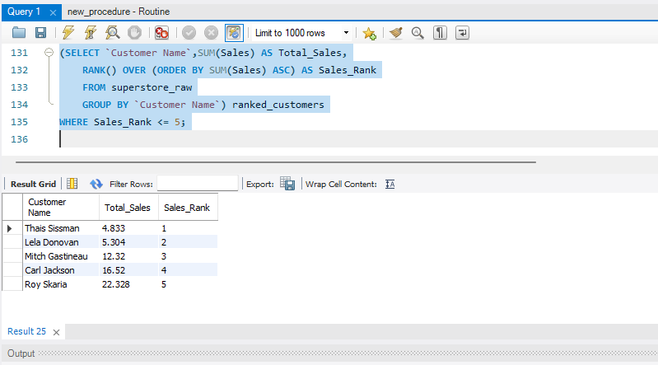

- Which customers made only one order?

ANSWER 3:

SELECT `Customer Name` , COUNT(`Order ID`) AS Order_Count
FROM superstore_raw
GROUP BY `Customer Name`
HAVING COUNT(`Order ID`) =1; 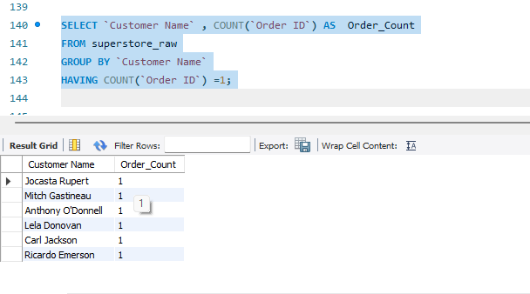

OUTPUT:

- Which customers have above-average sales?
ANSWER 4:

WITH customer_sales AS
(SELECT `Customer Name`, SUM(Sales) AS Customer_Sales
FROM superstore_raw
GROUP BY `Customer Name`)
SELECT `Customer Name`, Customer_Sales
FROM customer_sales
WHERE Customer_Sales > (SELECT AVG(Customer_Sales) FROM customer_sales);

OUTPUT:
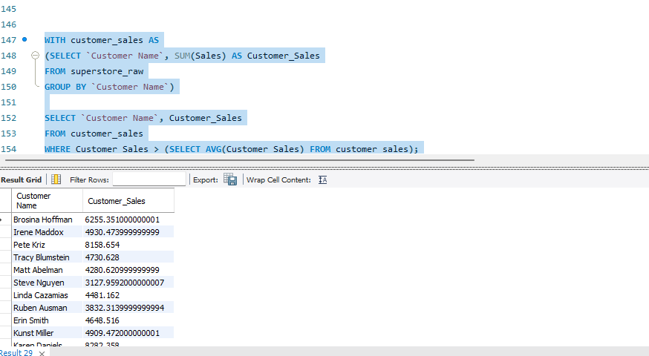

- What is the highest order value per customer?

ANSWER 5:

SELECT `Customer Name`, MAX(Sales) AS Highest_Order_Value
FROM superstore_raw
GROUP BY `Customer Name`;

OUTPUT:
